

Naaya administrator's manual
Naaya toolkit for EnviroWindows
Prepared by
Miruna Bădescu
October 2007
Version 1.0
User guide
Version management
No | Date | Changes | Author
1.0 | 10 Aug 2007 | First version | Miruna Bădescu
1.1 | 15 Oct 2007 | Users and security chapter added | Miruna Badescu

Project manager: Paolo Meozzi, EEA
Contents
1. Setting the scene 4
2. Terms, abbreviations and acronyms 4
3. Naaya overview 4
3.1. Extensibility 5
3.2. Modularity 5
3.3. Levels of administration 6
4. Content management 8
4.1. Content types 8
4.2. Publishing workflow 12
4.3. Folder-level 13
4.4. Portal administration 19
5. Translate the website 20
5.1. The language negotiation process 21
5.2. Multilingual content 22
5.3. Multilingual interface 23
5.4. Multilingual searches 24
5.5. Multilingual syndication 24
6. Change the layout 25
7. Users and security 27

Setting the scene
This document describes the content management and maintenance operations that an administrator of a Naaya portal for EnviroWindows can perform.
Currently, all EnviroWindows portals are hosted on the EEA server at http://root.ew.eea.europa.eu An application for creating a new portal on this same server can be made from the EnviroWindows website (http://ewindows.eu.org/applicants).
Alternatively, separate installations of the software can be done on different locations since Zope (released under the Zope Public License http://www.zope.org/Resources/License), Naaya and its extension for EnviroWindows (released under the Mozilla Public License http://www.mozilla.org/MPL/) are all open source applications.
Further details on Naaya installation issues do not fall into the subject of this guide, they are included in the Naaya installation instructions.
In the following, the assumption is that an EnviroWindows portal has been created and you administrative rights on it.

Terms, abbreviations and acronyms

Term | Definition
XML | eXtensible Markup Language
CMS | Content Management System
Zope | An open source application server for building content management systems, intranets, portals, and custom applications
ZMI | Zope Management Interface
PTK | Portal ToolKit
EnviroWindows | EEA platform for knowledge sharing and development
EW | EnviroWindows
TAL | Template Active Language, a scripting language for Zope
Remote channel | A summary of content published on the Web in XML format and updated on regular basis. Often referred to as “feed”. Content available in this format is parsed by websites, browsers and desktop applications and presented to visitors as listing of contained items (e.g. latest news from related site). Usually, the presence of RSS/RDF/ATOM feeds is signalled on websites using icons such as or .
Portlet | User interface components that are managed and displayed in a web portal. They produce fragments of markup code that are aggregated into a portal page, typically on the left or right sides of the page.

Naaya overview
Naaya is an open source portal toolkit with support for content management, multilinguality, syndication and friendly through-the-web site administration for webmasters with all kinds of technical backgrounds.
Naaya portals target users are people that want to quickly start a website and reduce to a minimum the need to refer to technical system administrators for its update and maintenance. They can delegate authority for content management and local administration to a team of non-technical contributors.
Things like access statistics, mapping domain names to the portal, running jobs at regular intervals, updating the software on the file system or installing new modules still require technical intervention, but these are not daily tasks and are usually taken care of by the network administrators.

Extensibility
This platform has been build in a flexible way, which allows:
- adding other components from the Zope open source community,
- replacing various modules to fit custom needs or
- enhancing existing components to comply with emerging Web standards or respond end user remands.
So, if you are working on a Naaya portal and need a functionality which is not included in the standard package, it is very likely that somebody already wrote an open source component for it (e.g. a blog product, integration with external databases); if this is not the case, an additional component can be developed and added to Naaya.
In comparison with other similar systems such as Plone, plugging generic components or integrating existing ones is quite straight forward and does not require extensive knowledge of the Naaya design and architecture.

Modularity
Naaya was built over the years, following the user requirements gathered from several European communities, but its features proved to be quite typical for most modern portals. Since various networks of portals as well as stand-alone applications are powered by Naaya, it was bound to contain very specific functionalities at some point.
That's why Naaya portals are based on a core set of generic modules to which a custom component can be added, in order to overwrite some functionality or add features only required in that context. EnviroWindows is one of this cases.
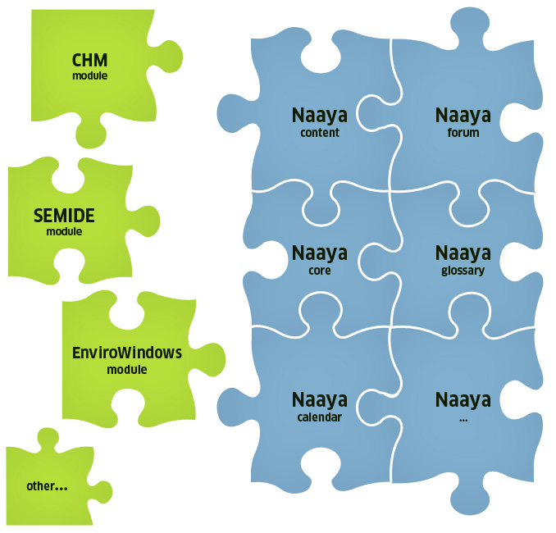Figure 1: Naaya - plug and play components
Moreover, after creating multiple portals on the same Zope server, they can be individually customised after creation. The layout, the wording on the forms, the portlets, etc. can differ, but also new functions can be written for each portal.

Levels of administration
The administration and maintenance of Naaya websites can be done from the ZMI (Zope Management Interface) by users having the Manager role in the portal. However, this management console is meant to be used by people with technical backgrounds and with a certain level of Zope knowledge.
Therefore, an Administration area is provided to facilitate users with the role of Administrator to make basic maintenance operations and customisations of their portal. Administrators are intended to be users with full decisional rights over the content and presentation of the portal, but not necessarily technical people.
The rights granted to an Administrator are included in the ones granted to a Manager so, when a person has the Manager role, there is no need for him or her to also have an Administrators role.
You can reach the Administration area by selecting the Administration option from the top services links list after logging in with the proper rights. In here, all functionalities are listed in the right-side Administration portlet.
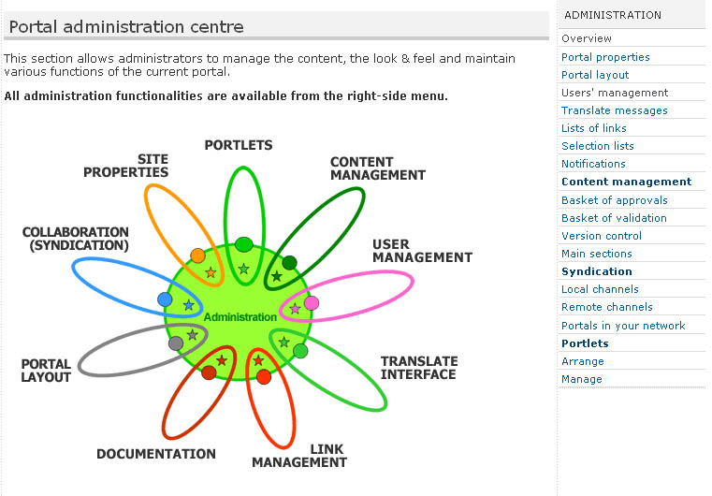Figure 2: Portal administration centre
Basically, all operations available from this administration centre are presented inside portal pages and therefore are easier to use because the sense of navigation in the website is maintained. Moreover, each page contains explanatory texts to guide users in executing the operations and help them understand the impact each operation will have to the portal.
On the other hand, the ZMI offers a much wider range of functions such as undo operations, database (ZODB) management, refined modifications to each Zope object, language management, administration of glossaries and thesauri, etc. For a basic understanding of Zope’s mechanisms and of the ZMI operations, read the online documentation at http://www.zope.org/Documentation/. The Naaya-related objects and operations that can be performed from the ZMI will be partially explained in this guide.
If you are logged into the system as a portal manager, you can reach the ZMI by typing the site URL followed by “/manage” in a browser:

http://<portal_url>/manage

Figure 3: Zope Management Interface
Aside from the portal-level administration, a folder-level one is available for local Administrators, in order to be able to;
- manage content in that folder and below in the hierarchy (sub-folders)
- manage the right-side portlets displayed here
- manage users
- potentially add a custom logo to be displayed in the right side of this folder and it’s sub-folders
- customize the site’s feedback form
Since the policy is for the portal administrator to fully delegate authority to local administrators, it is possible to allow visitors that navigate in these folders to send a feedback through the site’s feedback form either to the site administrator’s or to the local administrator.
Figure 4: Folder admin
Whenever a local administrator will log in and navigate to the folder they have this privilege into, they will see the right-side portlet called “Folder administration” that contains links to the functionalities described above.

Content management
Before explaining the operations that can be done upon the content, let's take a look at the content types available by default in EnviroWindows portals. As explained before, new types can be created and added as needed.

Content types
When you have a piece of information that you want to see published in the portal, the first step is to decide what type of content would better accommodate it. It is important to put the data in the right format because each type has a different set of attributes which can later be used to correctly index and categorise it.
All types have a common set of attributes that generically describe resources. They are called metadata. Since fully defining a resource implies generically describe it and also describing its custom characteristics, all Naaya content types have:
- a common set of properties (e.g. title, description, release date, contributor);
- a custom set of properties (e.g. location for events, expiration date for news);
- a dynamic set of properties, which are are only relevant for one website and are defined by Managers for each portal, individually (e,g, CV for experts).
Since multiple Naaya portals can reside together on the same Zope server, dynamic properties of objects allow fulfilling the needs of each portal without impacting on the genericness of the software product.
Managers need to enter the ZMI -> portal_dynamicproperties -> add “Naaya Dynamic properties item” for the content type they want to add properties to -> and define each additional property here.
Upon adding a dynamic property to a type of objects, it is immediately added to all existing objects with the predefined value you specify. New objects added from that point on will also have that property. Moreover, the submission and editing forms for those objects will automatically contain that field.
As you can see in the screen shot below, it is possible to choose the type, a predefined value, predefined list of choices, etc.
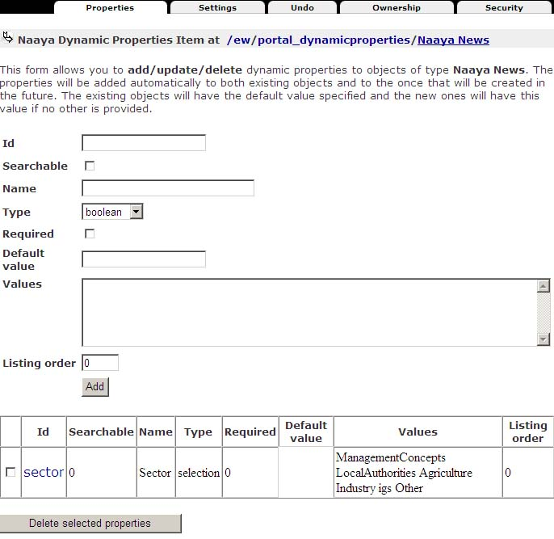Figure 1: Define dynamic properties for objects

Folder
Folders are containers of information, similar to the ones from the operating systems. They also have metadata attached, in order to help describe and the index the data inside them.
Throughout this user guide, folders will be also referred to as sections.

HTML document
Use this type to build a generic Web page. A friendly editor will help compose the pages, without you having to actually write HTML code.
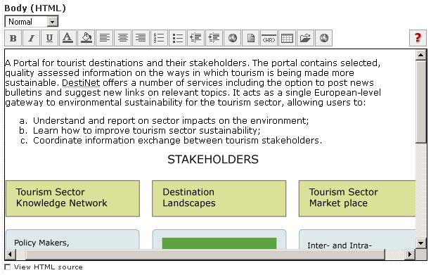Figure 5: HTML editor
At the time of writing of this version of the document, this editor is being replaced with a much enhanced one that offers a broader choice of options and completely eliminates the need to compose the page in editors such as MS Word or FrontPage first and then paste them into this editor.

File
A standard file, briefly described by its metadata. Visitors can download it on their computers or view it inside the browser - proving the right plug-in is installed.
It is possible to keep old versions of Naaya files for user consultation.

Extended file (multilingual)
The difference from the usual Naaya file is that different files can be stored for different languages. For instance, say you want to offer a PDF file for download in all portal languages. You will then use the Naaya Extended File and when translating the metadata (title, description, etc.) in the available languages, you need to also upload a different PDF file for each language.
This way, users will be able to read the entire document in the language of their navigation, not just its metadata.

Media file
When the need to display films, presentations, audio tracks or other multimedia materials inside the portal pages presents itself, you can use this content type to upload the film file any format.
The film will be converted by the system in an internal format (.flv) and displayed to visitors in a Flash player. The great advantage of using Flash against other a browser plug-in (e.g. Windows Media Player, QuickTime Player, etc.) is platform independence, along with removing the need for user to download the file on their computer prior to viewing it.
The Naaya Media File also allows inserting subtitles for each portal language.

News
The news item is a short piece of information with a limited duration of life. Traditionally, news have an expiration date which allows the latest ones to be displayed automatically on the front page and still not have outdated content there.
It is very simple to display news from remote sources of information in the portal pages and also to allow other websites to pick up the latest news from Naaya portals.

Event
Stores information about an event, a meeting, a conference, etc. The types of events are configurable at portal level (require manager intervention in the portal_properties object).
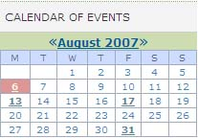Figure 6: RDF calendar
The events are also syndicated by default and they can be shown under the form of an events calendar. The RDF calendar is able to display events from various sources of information, including the local portal.

Story
The story is somewhat similar to the news, but with an unlimited duration of relevancy. Stories can contain a longer body, have pictures inserted in it and a small image to be displayed on the front page if necessary.

URL
URL objects contain links to remote pages. They are easy to check at regular intervals using an automatic link checkers and can be described by the metadata.

Pointer
Pointers are links to internal portal pages. When adding a pointer, a sitemap is displayed to pick from.
Since content can be moved, renamed or simply deleted, internal links may become broken in time. Broken pointers can be easily spotted by content managers using a script.

Expert
Data about an person that has expertise in the area of activity of the portal. The person's domain of expertise is added from a list configured at portal level.

Project
Data about a project that covers the area of interest of the portal. The focuses of the project come from a list defined at portal level.

Contact
Holds data about a person's credentials and contact details.

Geo Point
It contains data and geographical coordinates of a location which is represented on a Flash map. The background service for the map is currently offered by the EEA and it can be replaced with another service if needed.
The idea behind this tool is to publish text data about all sorts of locations relevant to the site in different folders as fit. Eventually, they can all be seen on the same map.
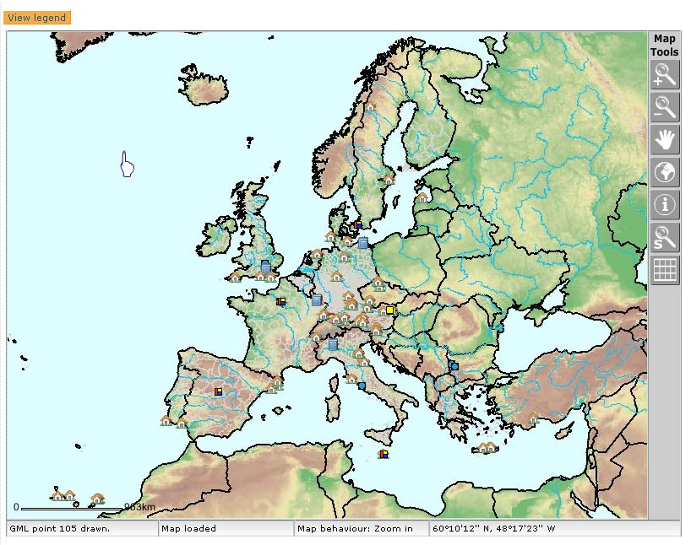Figure 2: Map for the geo points
At the time of writing the document, there are plans to enhance this type by adding automatic geo-coding (extraction of coordinates based on the address), more accurate coordinates, alternative backgrounds, etc.

Publishing workflow
The (default) publishing workflow of the Naaya websites allows a contributor to submit the content (news item, HTML page, expert data, etc.) and an administrator (or, of course, manager) to review and approve/delete it. Before an administrator’s approval, that content is available in the portal but not visible to regular visitors. For obvious reasons, content posted directly by administrators is immediately published in the portal.
This way, the administrators can appoint a few persons to gather and post content and still have the final decision on what is actually published on their portal with minimum effort. If the ‘Maintainer email” property for the a folder is filled in with the administrator’s email, he/she receives a notification each time a piece of content is submitted in the portal. Multiple addresses can be specified here separated by commas.
Then, they access the corresponding “Basket of approvals” form which lists the pending content, allows its viewing and editing and gives administrators the possibility to approve (publish) or delete each content item by just clicking on the corresponding checkbox.
The full publishing workflow of Naaya portals and the actors involved in it are described by the picture below:

Figure 7: Complete publishing workflow in Naaya

Folder-level
All content is published in folders across the portals so most of the content management facilities are available from each folder when logged on with a user that has proper rights (see section “Users and security” for more details).
The full set of possible operations is:
- edit folder properties including its metadata, maintainers emails, allowing user registrations, etc - “Edit Folder” button;
- publish pending items or revoke publishing status from the basket of approvals - “Approvals” button;
- quality assess old content from that folder and mark each item accordingly, from the “Validation” button; this function is meant for content reviewers that don't necessarily have administration rights and that examine and quality assess the content of a portal at regular intervals.
Mainly, they make sure that information is not obsolete and post a comment for items that need changing.
Administrators have an overview validation form in the administrative area, from which they have can see what content has been validated, when and easily see items that failed the validation along with the attached comments;
- setting the sort order of contained items (by default the items are sorted alphabetically by title) - “Sort order” button;
- restricting the folder from public view and granting access only to users with a certain role - “Restrict” button;
- cut/copy/paste objects from one folder to another (you need to make sure that you still have contribution rights in the target folder and that the target folder allows adding the copies/moved content types as sub-objects);
- delete one or more contained items;
- submit items of the types which are listed in the “Type to add” selection box;
- edit or work on a version for each contained item;

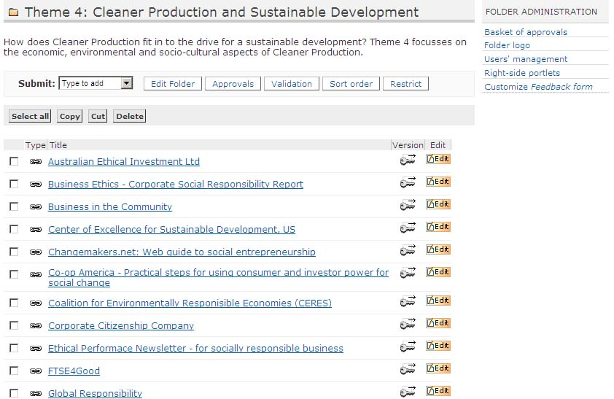Figure 8: Folder view for administrators

Local folder administration portlet
Aside from the content management operations, administrators can do more also at folder level:
- assign a logo which will be displayed on that folder and all its sub-folders;
- see the hierarchical basket of approvals (all pending content from that folder and it's subfolders);
- manage users at that level (grant/revoke local roles);
- display right-side portlets on that folder index;
- customise the feedback form at that level: when end users navigate through content from folder and click the “Feedback” link in order to contact the webmaster for questions and comments, they see a customised feedback form that goes to the local folder administrator and not at the site administrator.
All this functionality is also present in the administration area for the entire portal. The folder administration portlet offers quick links for administrators, but they are especially useful for local administration (users that have the Administrator role granted only for a folder, not for the entire site).
Therefore, it becomes easy for the webmaster of a Naaya portal to delegate authority for content management and site management onto trusted users, in the sections (folders) where their area of expertise is significant. The local administrators at their turn can do the same.

Default view and custom index
Naaya folders are shown to visitors as a listing of contained objects:
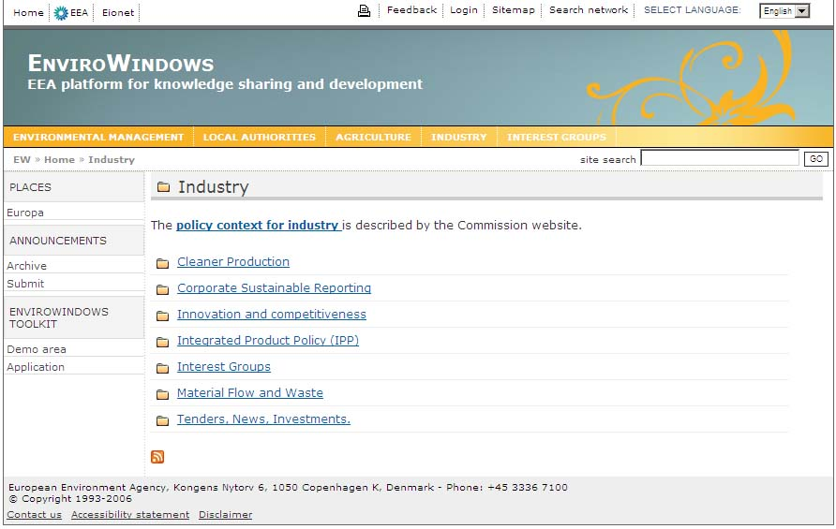Figure 3: Default display on a Naaya folder
The sub-folders are listed first, then the rest of the objects. Authenticated users with content management rights see more toolbars and links to functionality that they can access.
If you want to add introductory text before the actual listing, edit the folder and fill in its description. Chances are that you sometimes need another display for a folder: e.g. a custom search interface, showing graphs and charts.
In this cases, a Manager can enter the ZMI for that folder, access the “Properties” tab and check the “Use/create public interface” option. Now, a Page Template called “index” will appear in the folder content just in the ZMI, not on the public interface.
It contains a copy of the folder index page written in TAL (Zope's Template Active Language). Managers that have the necessary programming knowledge can modify it to define custom views.
In this manual, the default display of a folder or another object will be also referred to as index.
Only folder's indexes can be customised for a particular item since the need for other types of content to have individually different displays did not come up amongst our users.
In any case, the forms that define how each object is seen by visitors are available to Managers from the ZMI -> portal_forms, under self-explanatory names, such as folder_index, file_index, news_index, etc. Managers can also find here the add and edit forms for all objects in case they want to change something inside. All forms are written in Zope's scripting languages for the interface TAL and METAL.

Working on versions (check-in/check-out)
Sometimes, there is need to work a longer time on a content item and save temporary versions each time you complete a part of it. However, you don't want site visitors to see intermediary unfinished versions of that text because it could be misleading or even incorrect.
There is a simple way to do that for Naaya objects – start a version of the document. When you navigate in a folder, you'll see a small image (a key with an arrow on top of it pointing right) next to each item that allows versioning.
Figure 4: Inside a folder, "checkout" button for each item
This link is also provided when entering the object itself under the name “Checkout”. Upon clicking on this image/button, the item is reserved for your user to work on (having multiple users work on the same content in the same time leads to overwriting work). No one can now directly edit the item, just you can continue working on that version. Now the object looks like this:
Figure 5: Inside a folder, "version control" button for checked-out items
and the editing on a version form looks exactly like the usual editing one, aside from two extra buttons that permit to “Commit” or “Discard” the changes.
After multiple saving of changes (which are not visible to end users), the content manager commits (puts this version online) or discards (all the changes made since the version was opened are lost), allowing the item to be edited again.
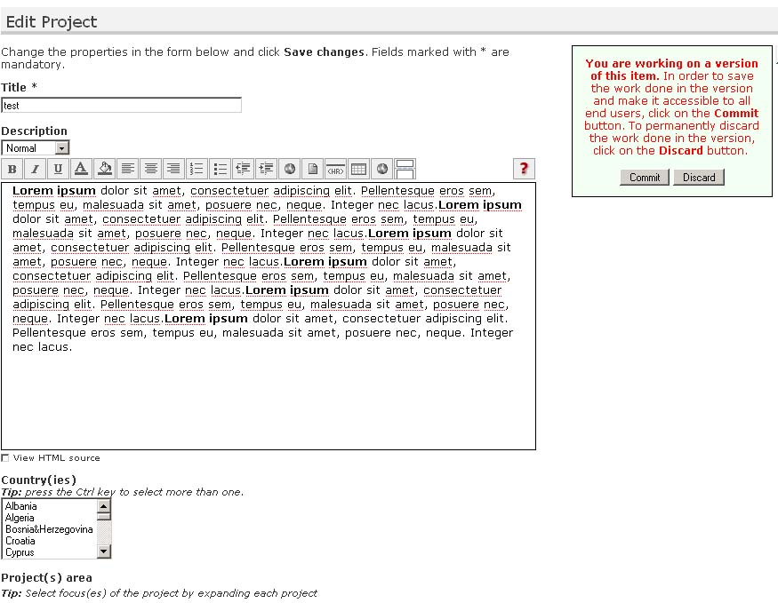Figure 9: Edit project on a version
As a safety measure, the administration form called “Version control” lists all items from the portal that have opened versions along with the user that opened them and allows administrators to discard changes that are not made by them (assuring that the content remains manageable after, for instance, someone resigns).

Comments to content
It is possible to open each piece of content for discussions by checking the “Open for comments” property when editing an item. Subsequently, a button saying “Login to add comments” or “Add comments” will appear to end users when they access that particular item of content.
By default, all visitors that have logged in the portal, regardless whether they have any roles or not, can post comments on items opened for discussions. The comments are shown in the order of their posting. When commenting, it is not possible to respond to a certain posting other that mentioning this in the text.
Administrators see a “Delete comment” button for each posting and, since the user name is displayed for each comment, they can take action (e.g. delete user) in case unwanted comments are posted.

Glossaries as picklists for metadata
The geographical coverage and keywords are part of the common metadata for all Naaya objects - they are actually Dublin Core (http://dublincore.org) elements. There is an important added value from properly indexing the portal content with terms took from controlled vocabularies, glossaries or thesauri.
Mainly, it leads to better search results from external search engines and the possibility to build guided searches in the portal, where people would be able to pick the search terms from the same glossary or thesaurus used to index the data.
Therefore, administrators can decide to allow content contributors pick from glossary words when filling the geographical coverage and keywords fields for each item. It can be accomplished by accessing the Administrative area -> Portal properties -> Other properties tab. On this form, choose a value from the “Keywords glossary” and/or “Geographical coverage glossary”.
You'll be given the possibility to choose among the glossaries available in your portal.
By default, none is available in EnviroWindows portals, but Naaya has support for multilingual glossaries and thesauri as separate products and one can be easily created and filled in with data for you by Managers.

Allow user registration
Each folder can have a link in the bottom of the page that only appears to visitors that have not logged in (yet). It leads to a form of registration and asking for contribution rights in that part of the portal or on the entire portals.
The result is that an email goes to the administrator(s) with that request. The administrator can simply access the User management form and grant the appropriate role to the user if needed. In any event, the user object is created upon submission of such request, even if no role is granted to it.
The fact that this link appears in the bottom of some folders is decided by the checking of the folder-level property “Allow users enrolment here?”.

Sub-objects
The list of object types you can add in a folder can be seen in the “Submit” selection box.
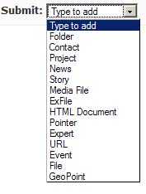Figure 10: Submit content in folders
There is a default set of Naaya objects that can be added in folders, established at portal level (ZMI -> portal_properties -> Subobjects tab).
So, when creating a new folder, content managers will be able to add those kinds of objects. It is also possible to change the sub-objects for each individual folders, also by accessing the ZMI for that folder (after the folder's URL type /manage) and from here cliking on the Subobjects tab.
When changing this list at portal level, only new folders created from that point on will have those setting, they would be applied on existing folders – it would be rather difficult to make automatic decisions on folders that might have custom lists. If you want to take out or add some content type throughout the portal, a Manager would have to create a Python script that does that.

Portal administration
The portal administration area contains a set of forms for:
- user management - allow managing users and their roles from one or multiple user repositories. EW portals usually use local users defined at portal level and Eionet LDAP users, since most of the players involved already have an account here;
- layout customisation;
- content management;
- syndication - allows defining and managing local and remote channels in XML format;
- translation centre for the messages across the portal;
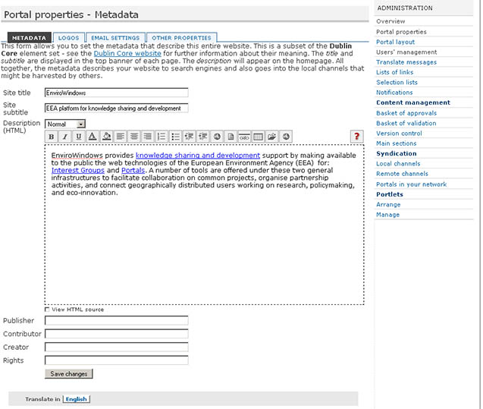Figure 11: Administration area, portal properties, metadata editing

Translate the website
Naaya portals are multilingual in terms of interface, content, search and syndication. Initially, the only available languages is English.
Managers can easily define additional languages in which the portal can be translated by using the Zope Management Interface. Add/remove languages operations can be done by accessing the Languages tab of the portal_properties object from the root of each Naaya portal;
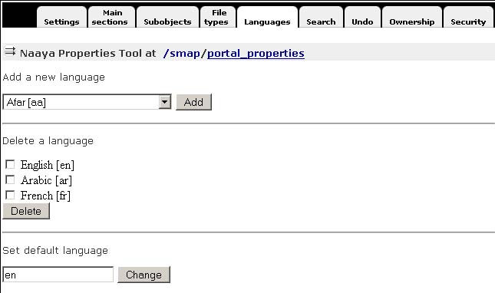Figure 12: Languages tab from portal_properties (ZMI)
Also from here, the default language of the portal can be set. Once a language is added or deleted, this is immediately reflected around the portal interface and content.
All Naaya portal pages are encoded in UTF-8(Unicode) which means that all characters and signs from any language are supported.

The language negotiation process
Here's the full language negotiation process:
- Navigation language (end user selection)
- Preferred local language (client’s browser or operating system)
- Default portal language
When an end user opens a page for the first time from this portal, a localization process takes place and the Navigation language is set. If any match is found between the list of available languages for the portal and the languages in the browsers preferences that language is set for the navigation language by default. If more language matches are found then the first one in the settings of the browser takes precedence.
The end user can manually select the navigation language at any time and from any portal page from the list of available languages. This will overwrite all other settings done automatically by the system:
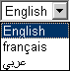Figure 13: Change languages selection box

Multilingual content
All types of content from the portal can be translated in each available language. An item can be added in just one language, which is the content contributor's choice (Posting language field on each submission form):

Figure 14: Add form for folders
After that, the item can be edited in order to be translated. On the editing form of each item, the “Translate in” banner appears in the bottom of the page and it contains the available languages as buttons, as shown in the figure below:
Figure 15: Translate content toolbar
Here is what happens when a piece of content (a folder, a file, a news item, etc.) is not translated in a certain language:
- first of all, the system searches for the translation in the portal default language (in this case English) and displays this one if available
- then, the system looks for a translation in the preferred local language (client’s browser or operating system) and displays this one if available
- finally, the system displays the item’s ID
This approach allows users to see that content exists in the portal and, even if they don’t understand the language that item is displayed in (because it hasn’t been translated in the chosen language) or the just ID is shown, at least they know that additional data is available and, upon increased interest, they can ask someone to translated the content or they can write to the webmaster and ask for the translation.
Note: not all the properties of content items need to be translated; some of them (e.g. dates, numbers, booleans, email addresses, some URLs) are not multilingual and will be filled automatically for each language on the editing forms.

Multilingual interface
All labels, explanatory messages, lists of links and their descriptions, the portlets (aside from the static ones) and other texts that appear on the user interface can be translated by specialised people in any of the available languages using the Translate messages form available in the administration centre. By default, only Administrators and Managers have the right to access this interface.
The translation centre for the interface lists the messages marked for translation in the portal and users can translate them individually. To ease the translation process, when a message is translated in a language, an OK sign will appear next to it in the language column. A message search is available which will narrow down the list of messages to those that contain a certain text. Users can sort the list of messages, both ascending and descending: alphabetically or by translation status in a certain language.
Figure 16: Translate messages from the administration area
Some of the messages contain HTML tags because splitting the texts around the tags would mean taking some phrases out of their context and therefore loose their meaning. All HTML tags MUST NOT be changed during the translation process.
When the portal has no translation for the navigation language it will attempt to find one in the languages from the settings of the browser. Ultimately the translation is shown in the default portal language.
Since the number of messages to translate is high, an export can be made in .PO or .XLIFF formats, the texts translated using external tools (e.g. text editors, specific translation tools) and imported back into the portal. Such operation can be made from the Import/Export tab of the Translate messages centre.
The PO file is a simple text file which will be downloaded with texts in English and the target language in which the messages have to be translated, while the XLIFF file is XML and it's very good when the translators use desktop programs that know to navigate among the messages, to suggest translations, search messages, escape HTML tags, etc.

Multilingual searches
The free text search available in the portal is performed in any subset of the available languages on the portal. For each result, links to other available translations are provided.
Figure 17: Multilingual free text search for the SMAP portal

Multilingual syndication
All local channels of information generated in RDF format can be downloaded by end users in the language selected in the browser. Only items which are translated in that language are included in the channel. An item is considered translated in a language if at least its title is translated.
When administrators define the relevant channels exposed by their website, they are able to choose the language in which each one of them is generated. Alternatively, they can choose the “Auto” option, which returns all items, regardless of their translation status in one language, applying the generic language negotiation algorithm.

Change the layout
The user interface for the portal is based on templates for header and footer. The generic page structure is detailed in the image below:
Figure 18: Generic page elements

Modifying the user interface can be done from the administration centre as follows:
- Portal properties -> Metadata for the editing of site title and subtitle and the front page description;
- Portal properties -> Logos for the modification of the top-left and right logos. The default EnviroWindows design doesn't have logos on the top banner, but it is simple to display them using this form;
- Portal layout - for choosing the layout and colour scheme used. By default, EW portals come with just one layout and 17 colour schemes, but others can be created from the ZMI by specialised people (e.g. Web designers) and later selected from this page
- Portlets -> manage and arrange - allows adding, changing, deleting and arranging the portlets, which care boxes containing information. The portlets can be arranged in the left and right sides on the pages and in the middle of the front page
Since the content is separated from the presentation and from the data, it is possible to create other layouts by accessing the ZMI -> portal_templates. In here, you'll find the EnviroWindows layout containing templates for the header, footer, left/center/right portlets and the colour schemes. Changing the template requires knowledge of TAL and METAL.
Creating or changing a colour scheme is however very simple for the web designers since they need to make a copy of an existing one and edit the CSS files and/or replace the few images used in designing the template.
Here are some previews of available colour schemes for EW portals:
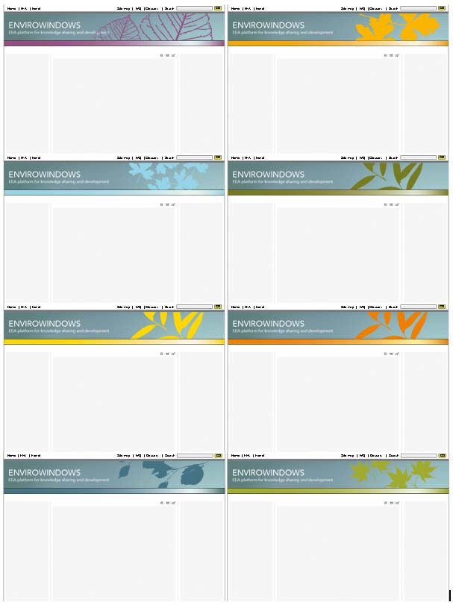Figure 19: EnwiroWindows colour schemes
Naaya websites are compliant with modern web standards such as:
- the website pages conform the Web Content Accessibility Guidelines 1.0 priority 2 (WAI-AA) for the end user interface
- the pages corresponding to the administrative areas of the portal are compliant to the Web Content Accessibility Guidelines 1.0 priority 1 (WAI-A)
- pages validate XHTML 1.0 Strict
- the mark-up respects the semantic HTML rules
- the Cascading Style Sheets respect the CSS2 Specification
- the portal has a user-friendly interface build with respect of the most important usability principles
- the website is usable in any web browser
- the site information is accessible to all users (including users with disabilities), to all types of devices (different browsers, PDAs and mobile phones, TVs, speech synthesizers, Braille interpreters, TVs, printers, etc.) and to search engines.
The portal has different display versions for print (contains only useful content and ignores navigation elements). Try printing a page without making any choices or additional settings from that page or browser.

Users and security
Three concepts govern the security mechanism in Zope and therefore in Naaya portals:
- Users
- Roles
- Permissions

